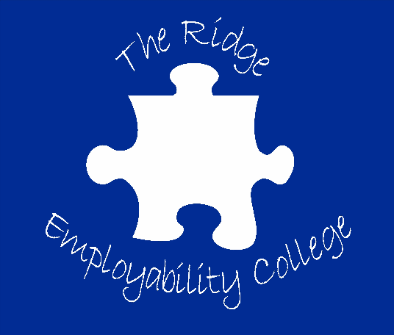

Life After College
Coffee Morning
Friday 7th March 2025 10am – 11.30am
This coffee morning is aimed at learners/parents/carers who are exploring provisions and support networks to help prepare for life after college.
Guests attending include: Representatives from Social Care, Department for Work & Pension, DICE, SMILE and Cambeth along with information from other providers.
Scan the QR code below to book your place.
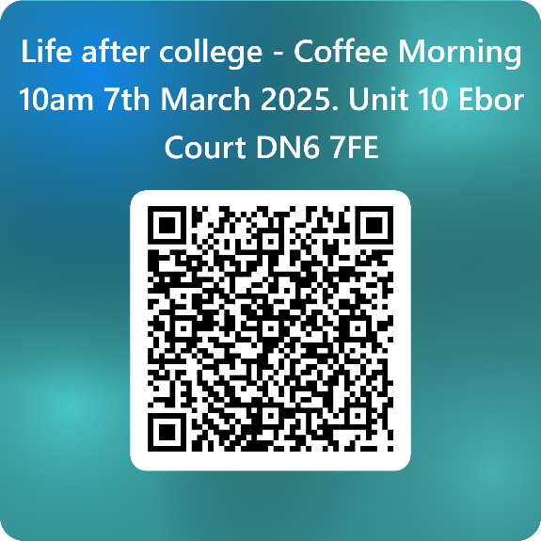
Unit 10 (Reception) Ebor Court
Malton Way, Adwick-Le-Street
Doncaster DN6 7FE

